System desgin problem

1.Uber system desgin

A)functional and non-functional reqirement

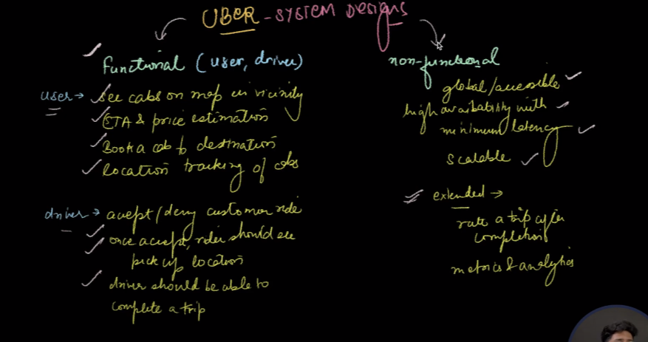

B.)Calculation and estimination

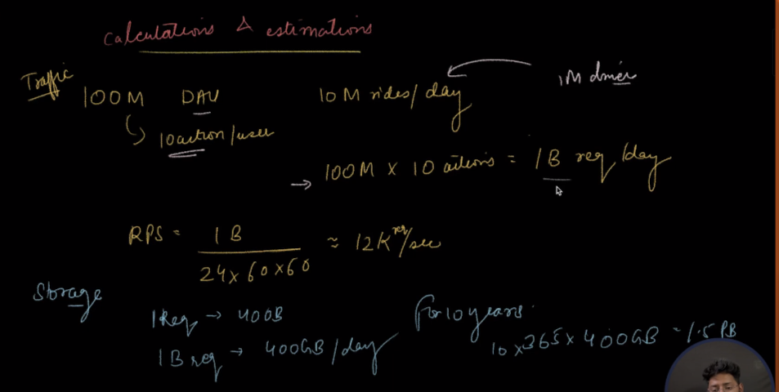

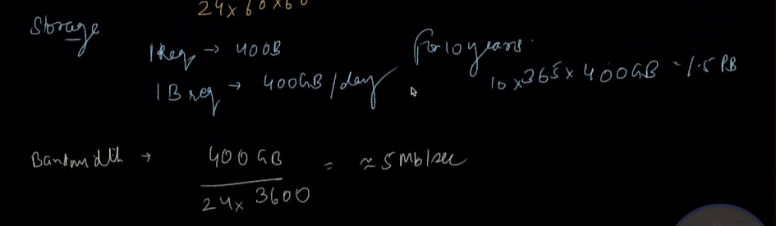

C)data modal design

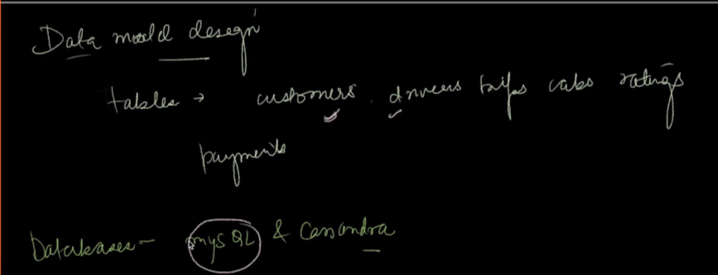

Database : mysql and casndra

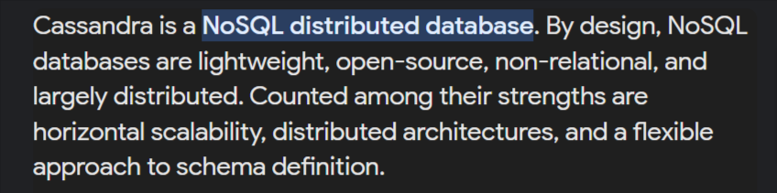

D)Arctitecture

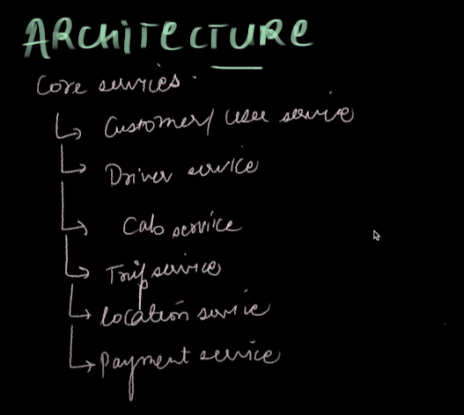

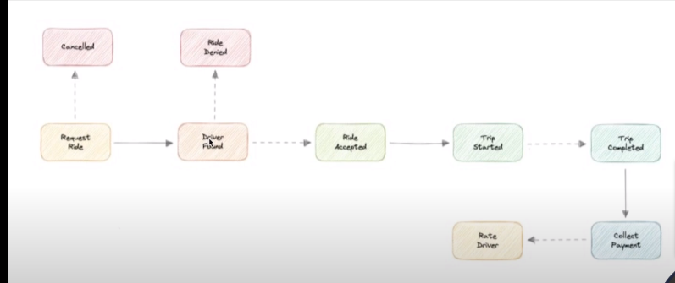

Cancelled=direver not found